NIHVA Self-reparable High Speed Door.
Self-repairable high-speed door, designed to efficiently separate areas with high traffic of people or vehicles. Engineered with cutting-edge technology, this door is built to withstand impacts without damage. Upon impact, it smoothly exits its guide, self-repairs, and seamlessly returns to its position, ready for continued use.
TECHNICAL DATA
- Application | Indoor and outdoor
- Structure | Galvanized steel
- Max. size | 5000 mm x 5000 mm
- Material-canvas | PVC Coated Fabric
- Max. speed | speed is 500mm/sec opening & closing.(can be increase up to 2000mm/sec)
- Safety | A running photocell and a safety light curtain.
- Certain color. | 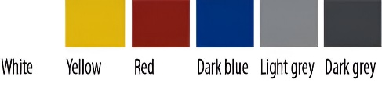  6 colors available. (vision panel is transparent)
Specifications:-
Application High | PVC curtain/Roller up door
Motor power | 0.55, 1.1 & 1.5 KW
Frequency converter | Yes
Force supervision | Yes
Diameter hollow shaft | 30 mm
Endurance | 60 c/h
Emergency release crank | Yes
Limit setting of door travel | Digital encoder
Force of mechanical brake | 8Nm 12Nm
Max door area | 9 m² to 25 m²
Features:-
- Longer Life Span
- High Tear Strength
- UV Resistant
- Flame Retardant (Chemically Treated to Self-Extinguish)
- Resistant to Humid Environment
- Simplified Maintenance (Easy To Clean & Maintain)
- 100% Recyclable
OPERATION
The motorization of the door is formed by a reducing motor of up to 1.1 kW fed to a single-phase voltage of 230 V through a frequency inverter and a control panel. This system regulates the motor’s speed when the canvas gets closer to the highest point and also to the lowest, reducing any vibration and giving a longer life to the set.
The motor with digital encoder allows faster openings and closures when it rotates the canvas cylinder to open or to close the door.
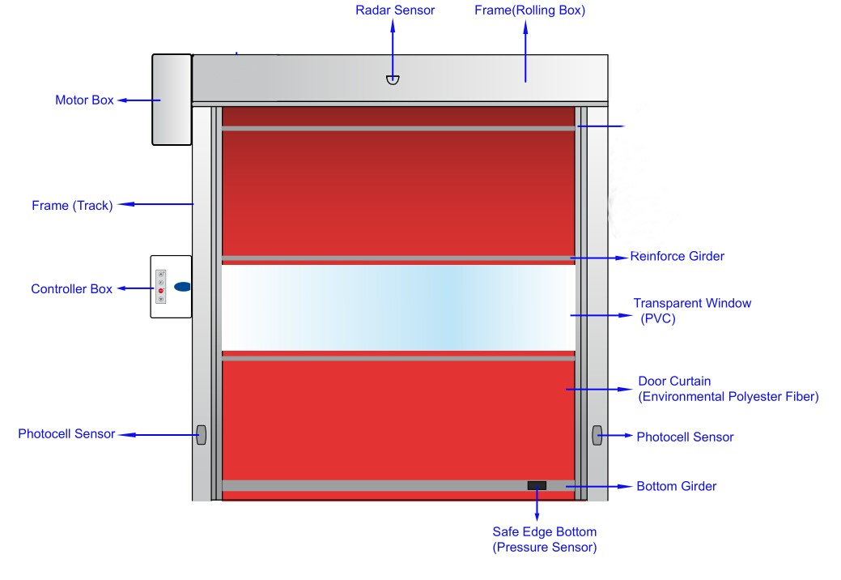In the event of blackout, it is possible to declutch the motor and use the handle to open or to close the door.

The door is composed by a high resistance polyester fiber canvas coated with PVC, attached to a galvanized steel frame. It incorporates a motor with reducer driven by a control panel and a frequency converter that guarantees a smooth operation extending the useful life of the door.
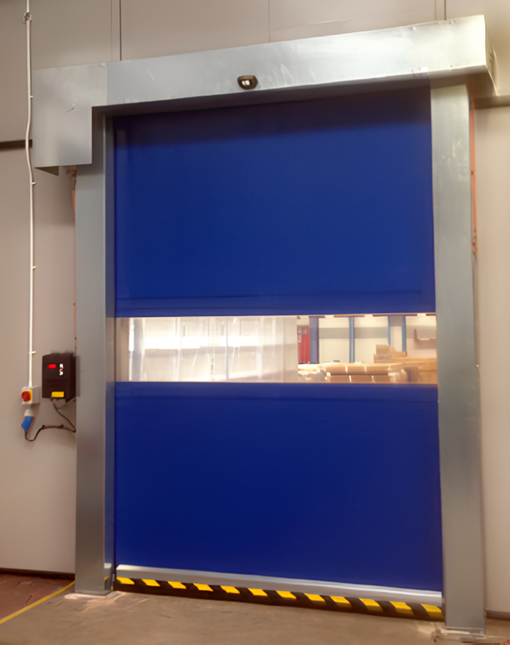
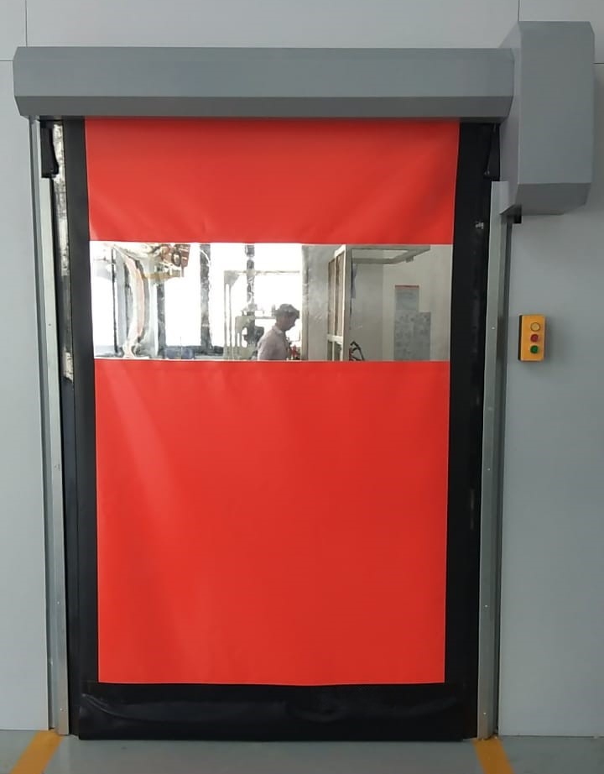

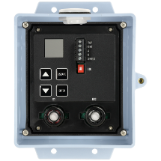
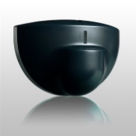
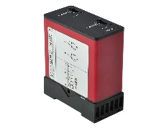
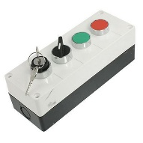
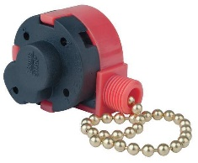
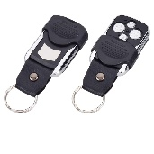
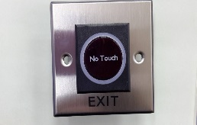
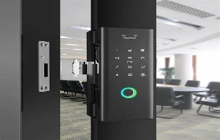
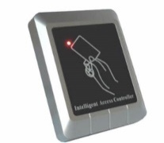
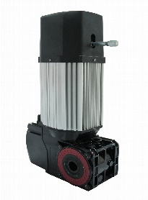
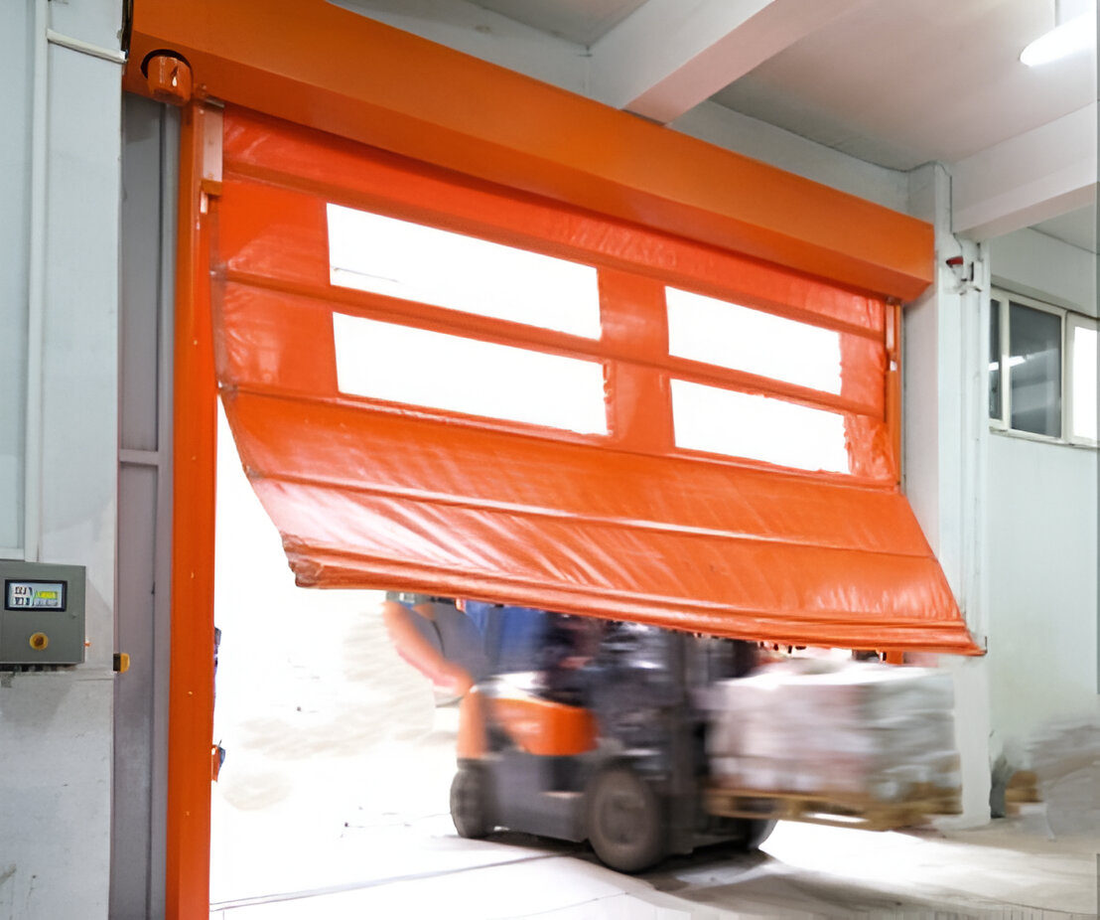
Other Accessories:
Motion sensor
No touch switch
Pull cord

3 way Push button
Loop dictator
Panel control
Biometric system

Remote
RFID card sensor
High speed Motor
NIHVA Technologies Pvt.ltd.
187, G-Block, 1st floor, Above Kotak Mahindra bank, MIDC, Chinchwad, Pune – 411019
Contact no- Email Id- website

